Project Design Phase-II
Data Flow Diagrams & User Stories
Date | 29 September 2026
Team ID | SWTID-2026-7108
Project Name | Ai-WeatherWise API

Data Flow Diagrams
A Data Flow Diagram (DFD) is a visual representation of the information flow within a system. It shows how data enters and leaves the system, what changes the information and where data is stored.
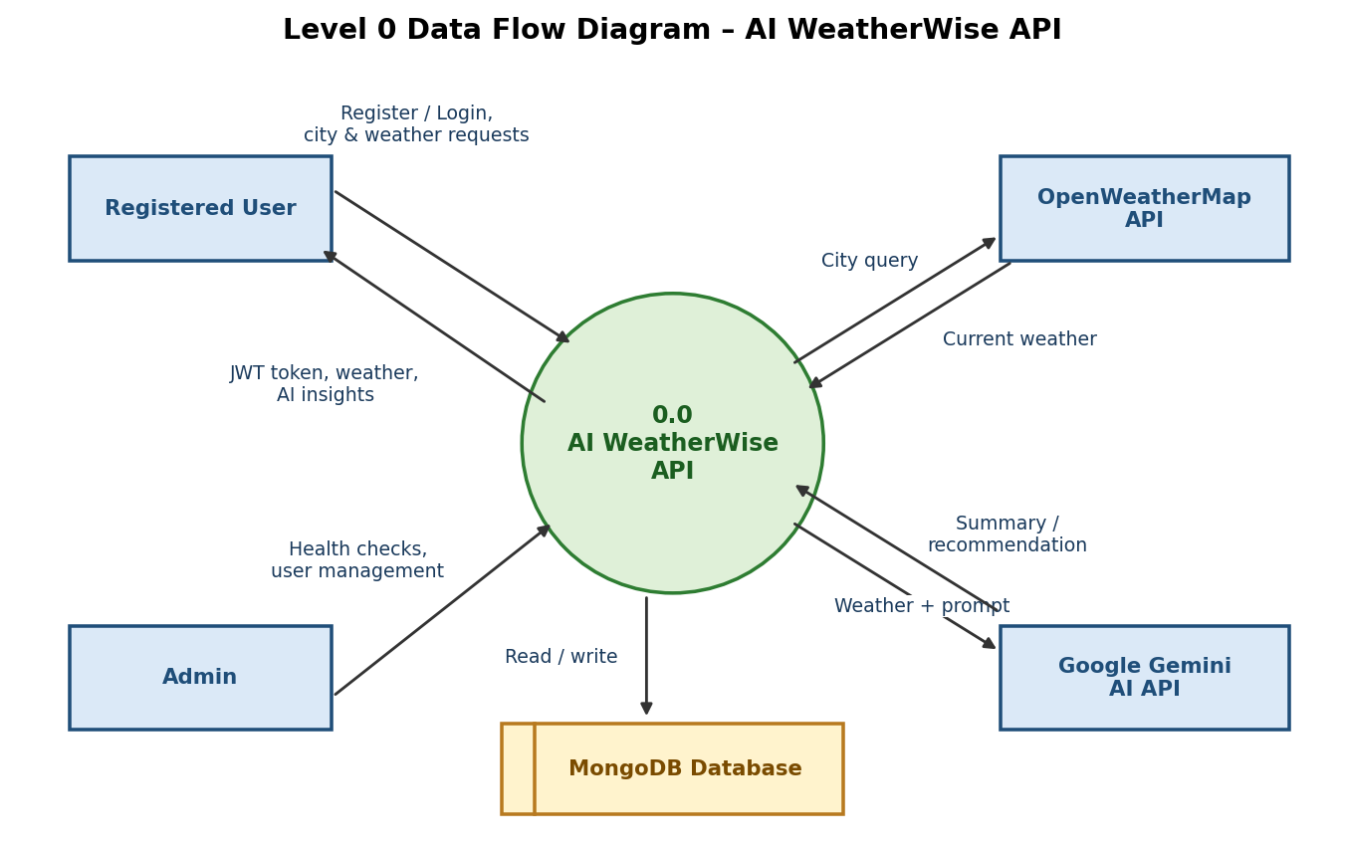
Figure 1: Level 0 DFD – AI WeatherWise API
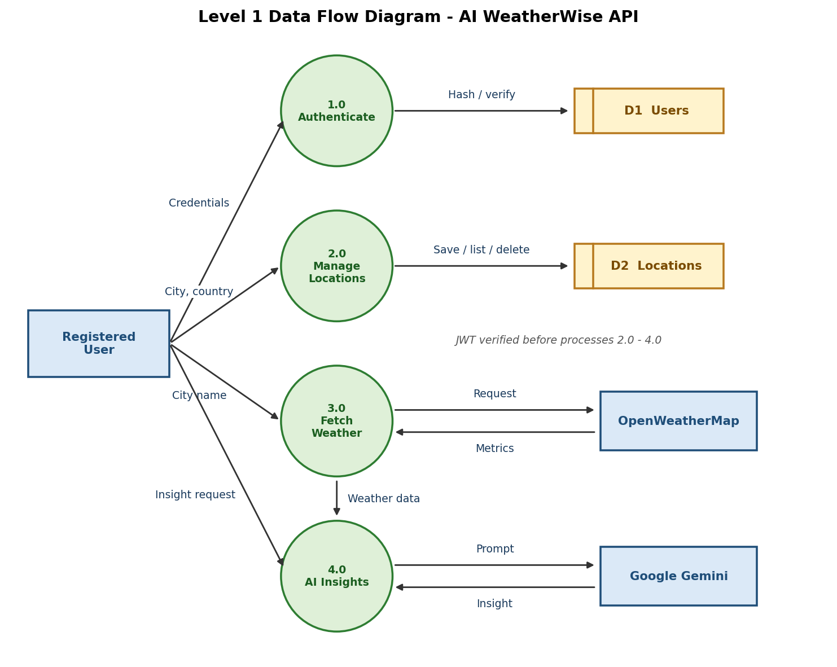
Figure 2: Level 1 DFD – AI WeatherWise API

User Stories
User Type | Functional Requirement (Epic) | User Story No. | User Story / Task | Acceptance Criteria | Priority | Release
Registered User | Registration | USN-1 | As a user, I can register with my name, email and password. | Account is created and a JWT token is returned (201). | High | Sprint-1
Registered User | Login | USN-2 | As a user, I can log in with my email and password. | Valid credentials return a JWT token (200). | High | Sprint-1
Registered User | Favourite Locations | USN-3 | As a user, I can save a favourite city and country. | City is stored against my account; duplicates are rejected. | High | Sprint-2
Registered User | Favourite Locations | USN-4 | As a user, I can view and delete my saved cities. | Only my own cities are listed or removed. | Medium | Sprint-2
Registered User | Weather | USN-5 | As a user, I can fetch real-time weather for a city. | Temperature, humidity, wind speed and condition are returned. | High | Sprint-2
Registered User | AI Insights | USN-6 | As a user, I can request an AI summary and recommendation for the weather. | Gemini returns a short summary or recommendation. | High | Sprint-3
Weather App User | Weather | USN-7 | As a public user, I can read current weather without an account. | Public weather endpoint responds without a token. | Medium | Sprint-2
Admin | Administration | USN-8 | As an admin, I can monitor API health and verify service integrations. | Errors are logged; the API works in fallback mode when keys are missing. | Medium | Sprint-3

